Deployed AIR FORCE Family DInner

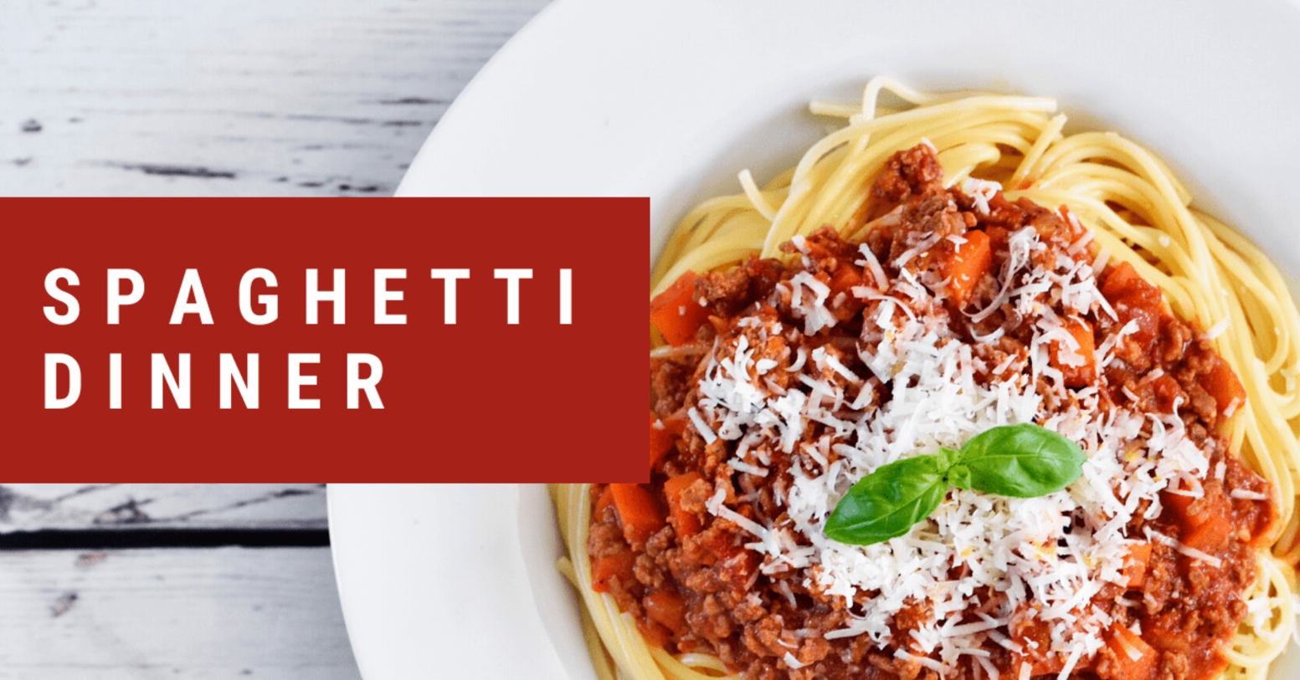
The 15th WG Chapel would like to invite the families of our deployed or soon to be deployed Airmen to a free spaghetti dinner. We will have guest speakers from the Military and Family Support Center (MFSC) and holiday activities for your children. Join us to meet other families and learn about the supportive resources available to you!
Thursday, December 2nd, 2021, 5:00 PM
Nelles Chapel Annex 9th & Signer Blvd, JBPHH, HI 96818
Sign up via the link below:
https://www.eventbrite.com/e/deployed-family-dinner-tickets-214787754957
Sponsored by
Hickam Chapel Center ● POC: Chaplain Kevin Pugh ● (808) 449-1754

